E-COMMERCE APPLICATION DEVELOPMENT
Collaborative Git Workflow, Branching, Merging & Conflict Resolution
Project note: This deliverable includes a runnable browser-based demo, a local Git repository with simulated developer identities and feature branches, deliberate merge-conflict resolution, and this report. It is not connected to a real GitHub remote because no GitHub repository URL was supplied.

1. Application overview
ShopSphere is a lightweight e-commerce demo built with HTML, CSS and JavaScript. It demonstrates registration/login, product catalogue and search, shopping cart, order management, simulated checkout/payment, and an admin inventory dashboard. Data persists in browser localStorage.
Security limitation: this is an educational front-end prototype. It does not provide production authentication, server-side authorization, secure password storage, inventory locking or real payment processing. Do not enter real credentials or card details.

2. Branching and team strategy
Use a Git Flow-style strategy: main is the stable release branch; develop is the shared integration line; each developer creates a feature branch from the latest develop. Feature branches are reviewed and merged into develop, then develop is merged into main.
Branch | Responsibility | Developer
main | Release-ready application | Maintainer
develop | Integration/testing | Integration Lead
feature/auth | Registration and login | Developer A
feature/catalog-search | Product search/catalogue | Developer B
feature/cart | Cart operations | Developer C
feature/orders-payment | Orders/payment simulation | Developer D
feature/admin-dashboard | Admin inventory | Developer E

3. Repository setup
The project starts with index.html, styles.css, src/app.js, README.md and documentation. Commands used:
git init -b main
git add .
git commit -m "chore: create ShopSphere application skeleton"
git branch develop
git switch develop

4. Feature branch and incremental commits
Example commands for a developer working on the cart feature:
git switch develop
git pull origin develop
git switch -c feature/cart
git add src/app.js docs/features/cart.md
git commit -m "feat(cart): add cart operations"
git commit -am "test(cart): document local verification"
git push -u origin feature/cart
The included repository has five feature branches, separate developer author identities, and multiple incremental commits.
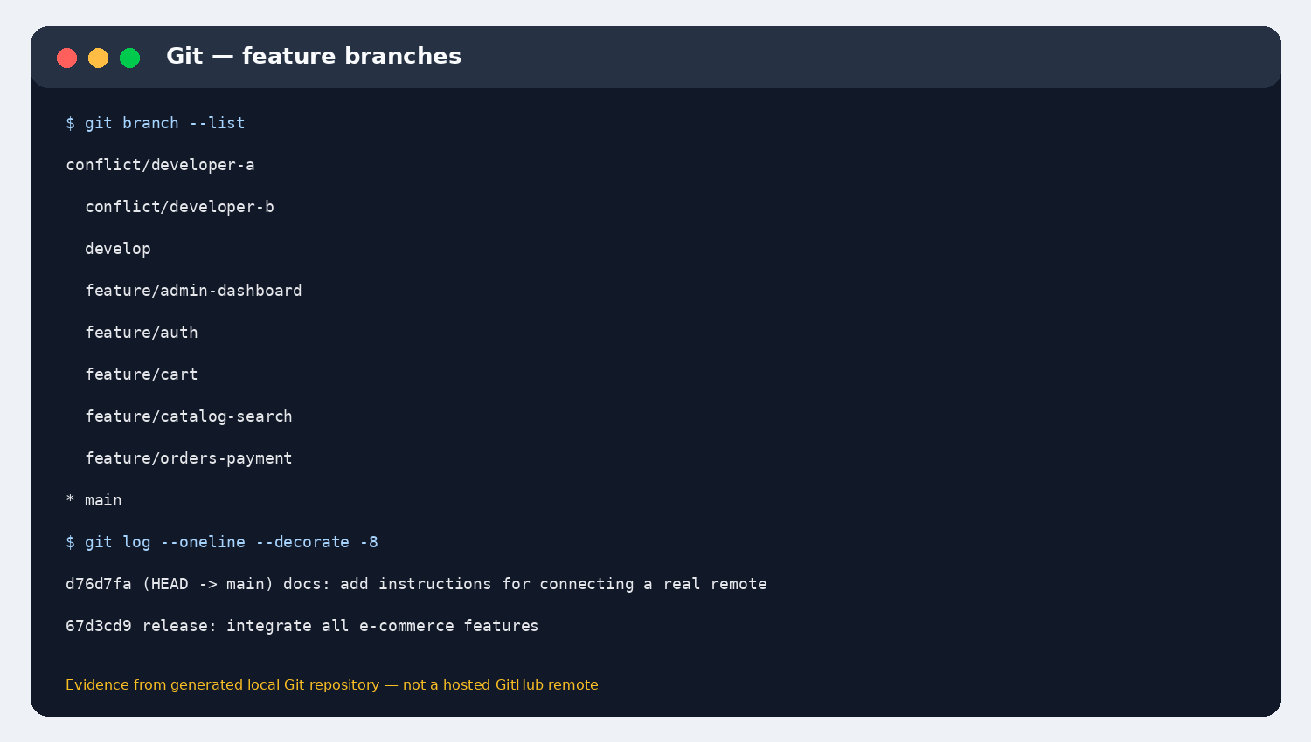
Figure 1. Feature branches and commit history.

5. Synchronizing with the remote development line
In a real team repository, developers fetch the latest changes and rebase or merge develop into their feature branch before opening a pull request:
git fetch origin
git switch feature/cart
git rebase origin/develop
git push --force-with-lease
git switch develop
git pull origin develop
Alternatively, use git merge origin/develop instead of rebase. Avoid rebasing a branch that teammates are actively using unless the team agrees.

6. Progressive feature integration
Feature branches are merged progressively into develop. No-fast-forward merges preserve visible integration points:
git switch develop
git merge --no-ff feature/auth
git merge --no-ff feature/catalog-search
git merge --no-ff feature/cart
git merge --no-ff feature/orders-payment
git merge --no-ff feature/admin-dashboard

7. Deliberate merge conflict
Two developers independently changed the same line in docs/shared-release-note.txt. Developer A recorded authentication/catalogue readiness; Developer B recorded checkout/orders readiness. Git reported a content conflict and paused the merge.
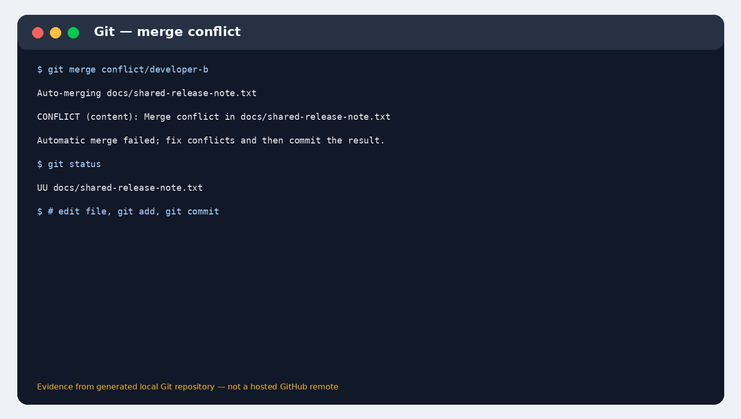
Figure 2. Git conflict output from the deliberate overlapping edit.
Resolution steps:
- Run git status and locate the unmerged file.
- Inspect the conflict markers and compare both versions.
- Combine all valid information in one coherent final version.
- Remove conflict markers, save the file and run git add docs/shared-release-note.txt.
- Commit the resolution and run the test plan.
- Inspect git log --graph --oneline --all before final integration.
The resolved file retains both developers' valid updates. The integration lead did not blindly choose ours or theirs.

8. Final integration and verification
After all features are merged into develop, merge develop into main and verify the working tree:
git switch main
git merge --no-ff develop -m "release: integrate all e-commerce features"
git status --short --branch
git diff --check
git log --graph --oneline --decorate --all
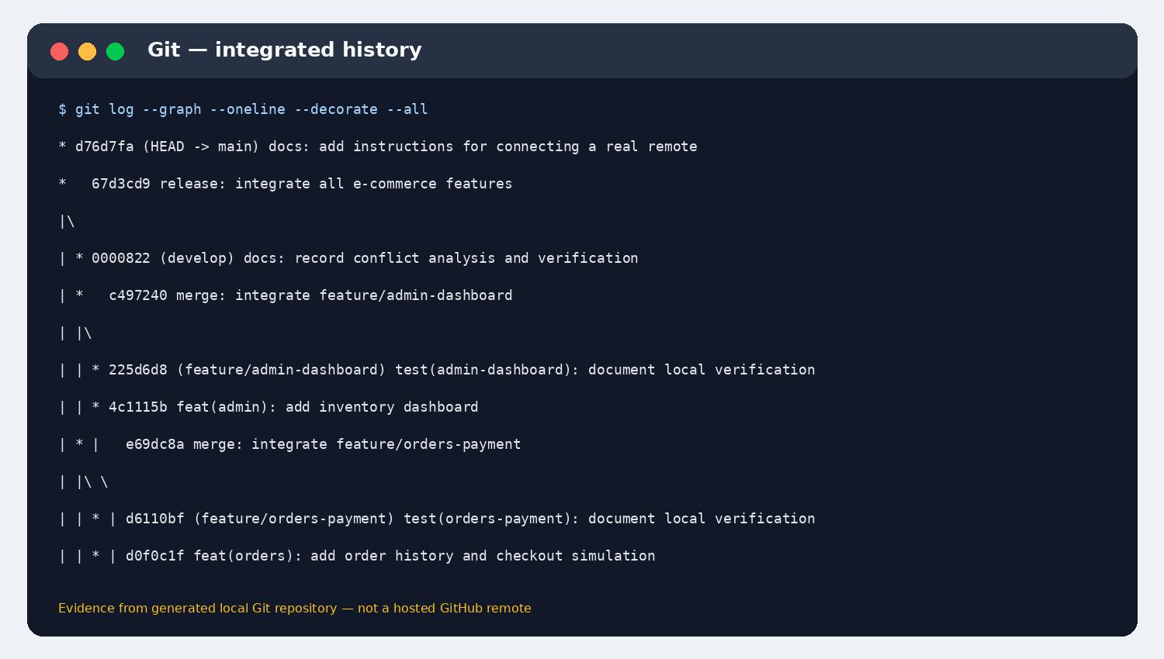
Figure 3. Final integrated commit graph.
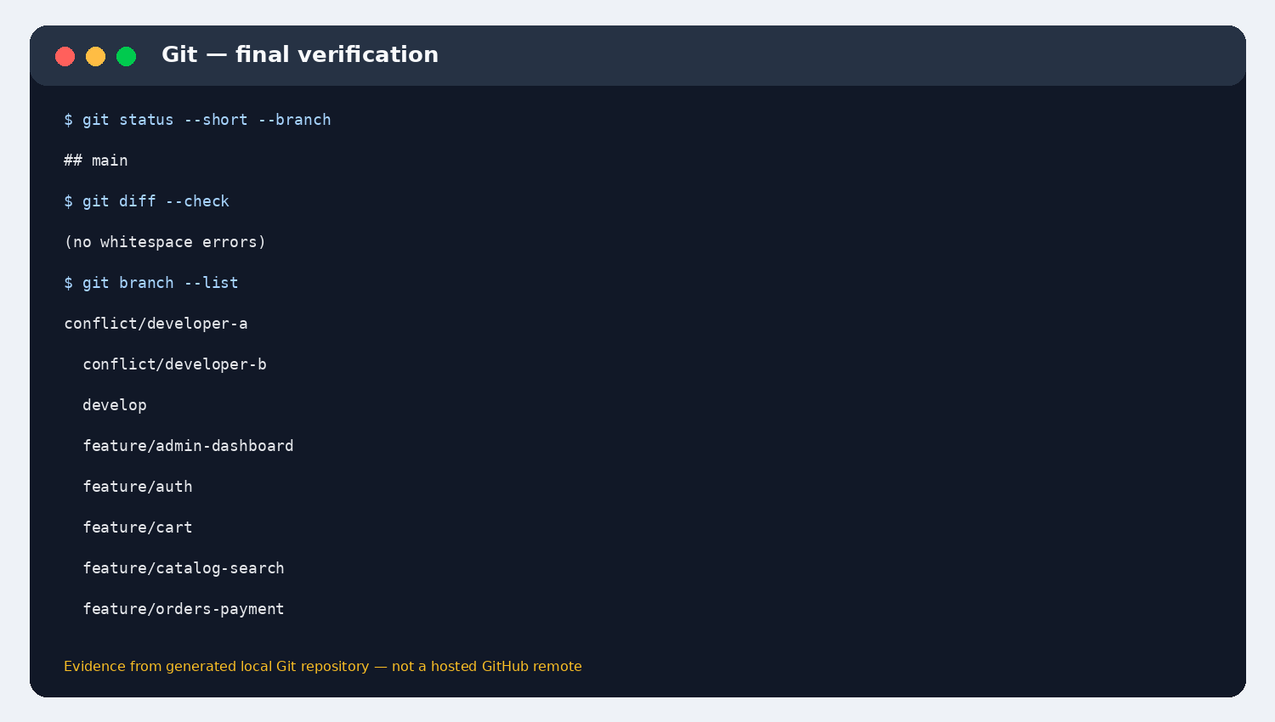
Figure 4. Final branch and working-tree verification.

9. Application testing checklist
- Register a demo account and log in/log out.
- Search for a product and filter by category.
- Add products to the cart and remove an item.
- Complete simulated checkout and verify order history.
- Open Admin and increment a stock count.
- Refresh and verify browser-local data persists.
- Check the browser console for JavaScript errors.

10. Connect to GitHub and submit
The ZIP contains the application and complete local .git history. To connect it to your own GitHub repository, create an empty repository and run from the project folder:
git remote add origin https://github.com/YOUR-USERNAME/ecommerce-collab-project.git
git push -u origin main
git push origin --all
Replace YOUR-USERNAME with your GitHub username. Enable GitHub Pages from main / (root); index.html is the landing page. The repository has not been pushed to a real remote because no account or repository URL was provided.

11. Included deliverables
The ZIP contains index.html, styles.css, src/app.js, feature documentation, conflict-resolution notes, remote setup instructions and the full local Git history. Extract it, then open index.html in a browser to try ShopSphere.

